Rounding error and test of normality

There is a common statistical test called Anderson-Darling (AD), (see the literature for details). It is very often used to test the normality of a set of data and is routinely incorporated in common computer programs. However, the normal distribution is a continuous distribution and thus numerical values have (theoretically) an unlimited number of decimals while real measurements always carry a limited, often small, number of decimals. This paper shows, by simulation, how the test is influenced by number of decimals but also how adding a small random term improves the result.
(NB that a set of data having a limited number of decimals is formally a discrete distribution and thus, by definition, not a normal distribution and thus correctly rejected by the test. Although, such an interpretation is usually too strict and perhaps useless).
The Minitab macro %Rounding (available by request) performs the simulation using parameters set by the user.

- Introduction of the macro
- Rounding of data and normality test (fig 1)
- Rounding of data and normality test (fig 2)
- Rounding of data and normality test (fig 3)
- Rounding of data and normality test (fig 4)
- Summary

1. Introduction of the macro
The macro does not discuss the very theoretical aspects of the AD-test nor how it is derived (see the literature for these features). The macro is started by typing %Rounding at the Minitab-prompt.
At the initial run, the macro uses the parameters stored in column c1 but different values can be used at a rerun. See also column c4 for suggested exercises. All the simulated data values are stored in the worksheet, including the rounded data. This makes it possible to use the standard menus to perform the tests. (The figure below is a screen shot of the macro after an initial run). The macro treats data with 1, 2, or 3 decimal places, the most common range in industrial applications.
Column c13 of the worksheet contains the AD-values of ‘fig 2’ and the AD-values when a small random-term is added to the data.

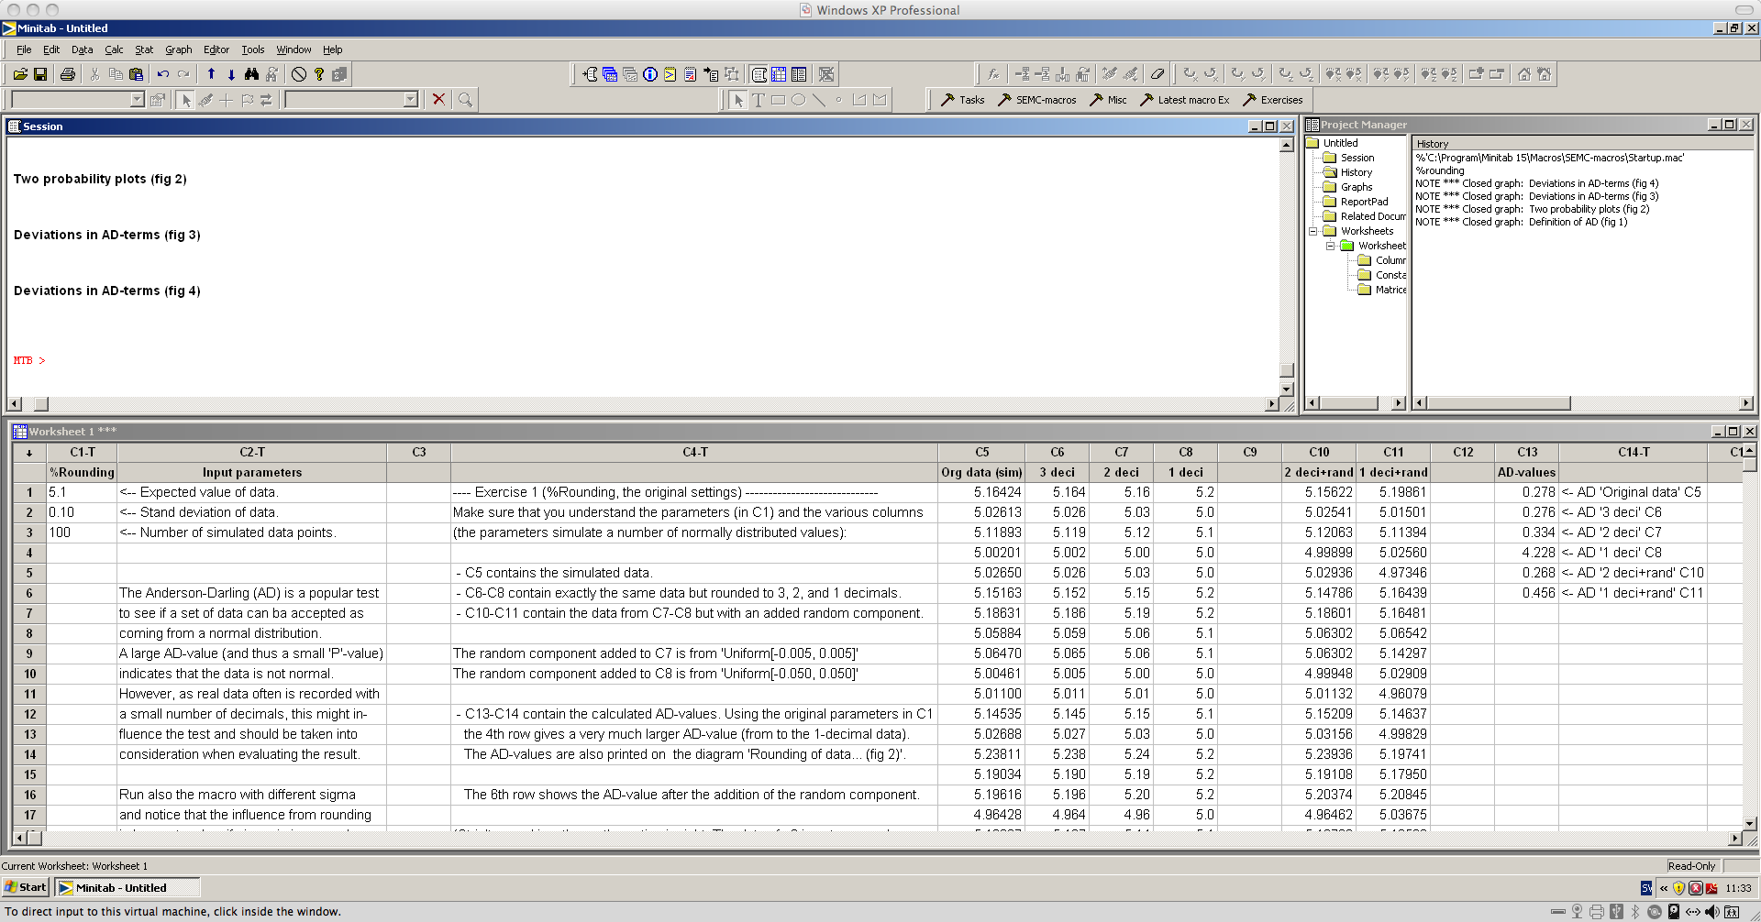

2. Rounding of data and normality test (fig 1)
The very mathematical expression of the AD-calculation contains n (number of values) and X_{i} (each measurement) and the CDF-values, see ‘fig 1’ below (the CDF is the ‘Probability Plot’ or ‘Empirical CDF’ under the [Graph]-menu). A CDF-value is a probability and thus a value in the range [0, 1]. A large AD-value indicates that the dataset does not come from the considered distribution. The printout in ‘fig 2’ also supplies a probability value (‘P’) and a low probability value supports the decision that the dataset does not follow the distribution (‘low’ has here the same interpretation as in ordinary test of hypotheses).
The AD-value is calculated as a sum of values, one for every row of the data. This information is used in ‘fig 3’ and ‘fig 4’ below.

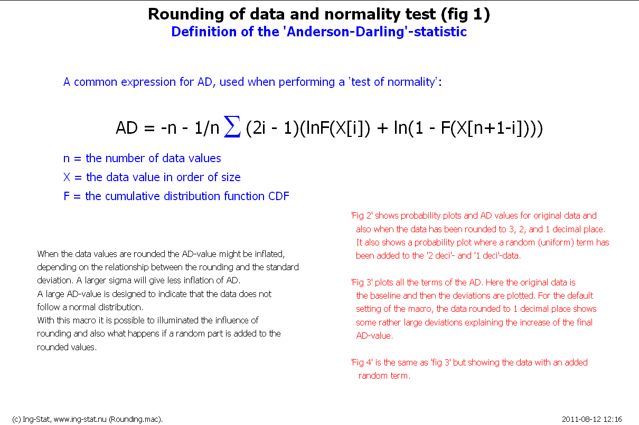 | This display shows the formula for the AD value and a short description of the following diagrams.  The display is shown only once and is not repeated when the macro is rerun with other parameter values.  The following diagrams will show that by adding a small random term to the data, the AD-values decrease.  And adding a random term is reasonable, after all, this makes the data more like the original data (the rounding is man-made because of limitation in equipment, etc.)

Below the diagrams show the results from different number of decimal places of the data.

3. Rounding of data and normality test (fig 2)
The graph ‘fig 2’ contains two probability plots. The top one shows the originally simulated data and also the same data rounded to 3, 2, and 1 decimal places. The table to the right shows a summary for each dataset (mean, standard deviation, number of values and calculated AD-value and corresponding p-values). The display also shows the theoretical mean (5.1) and standard deviation (0.10) used for the initial simulation.
In the top plot it is obvious how the data is placed in discrete spots on the X-axis, especially when rounded to 1 decimal. The corresponding AD-value is high and the corresponding p-value is very low. The test does not reject the first three data sets (original, 3- and 2-decimals) but rejects the data rounded to 1 decimal.
The bottom plot shows the same info as the top plot but here we have added a uniformly distributed random value to each measurement. This little trick removed the large AD-value and thus the rejection of the dataset. The trick of adding a random component has many good sides, see trick 2 on www.ing-stat.se and button [Tips&tricks] and the summary below.

The added random terms are uniform from the range [-0.005; 0.005] for the data with 2 decimals and uniform from the range [-0.05; 0.05] for the data with 1 decimal. This is programmed in the macro.

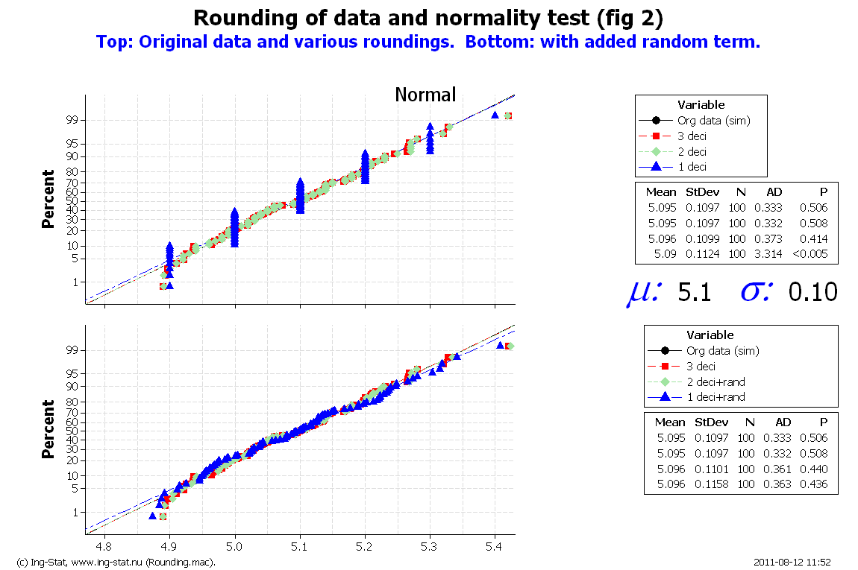 | The graph to the left contains two probability plots. The top one shows the results for the original data and the data rounded to different number of decimals.  The bottom probability plot shows the same data but here there is a random term added to the rounded data.  The display also shows the theoretical parameters used for this particular simulation. These values can be changed in column c1 of the worksheet.

The following diagrams show some peculiarities when plotting the deviations in the calculated terms of the AD-value.

4. Rounding of data and normality test (fig 3)
‘Fig 3’ shows three different series of data calculated in the following way: firstly, using the formula presented in ‘fig 1’, a column of values is calculated for the original simulated data and for the data ‘3 decimals’, ‘2 decimals’ and ‘1 decimal’. Let us call these four columns A, B, C, and D.
Secondly, the deviations A-B, A-C, A-D, three new columns are created and these three columns are finally plotted in ‘fig 3’. It is obvious that the deviations A-D (i.e. the deviations between the AD-calculation of original data and the AD-calculation for data rounded to 1 decimal) shows a peculiar pattern (green dots) and with some large deviations (at least compared to the other two series shown with black and red symbols). (We do not try to understand or explain why the deviations show this pattern).

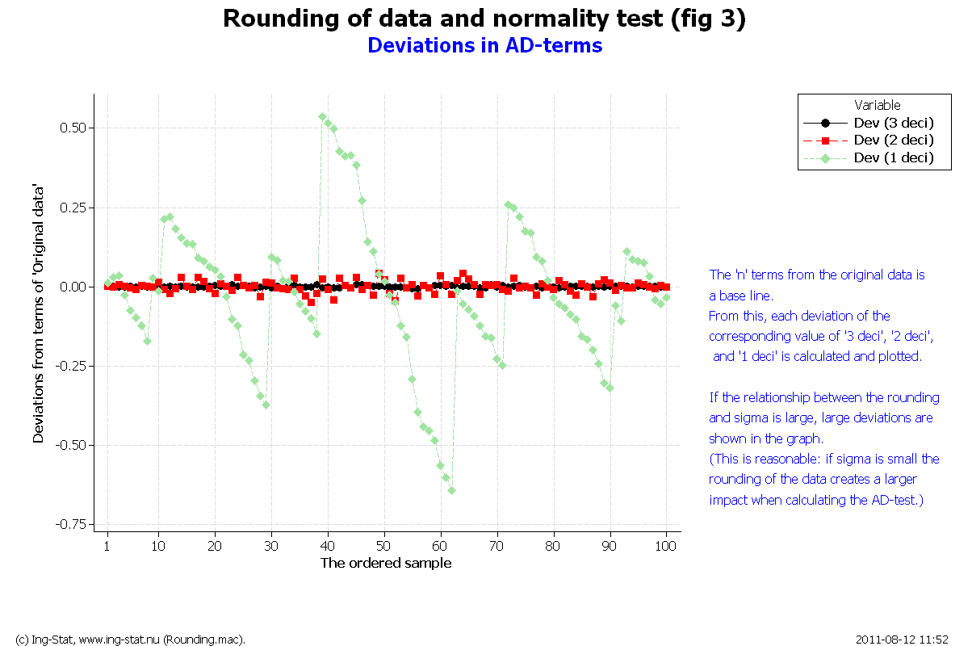 | The diagram contains three series of data. These show the deviations of the AD-calculations for the original data and for the rounding (3, 2, 1 decimals).  The results for the original data is used as reference and thus there are three sets of data (see also the text).

The final display, ‘fig 4’, shows how the patterns of ‘fig 3’ is removed together with the large deviations which finally leads to the smaller AD-value displayed in ‘fig 2’.

5. Rounding of data and normality test (fig 4)
‘Fig 4’ shows the same ideas as ‘fig 3’ but here there was a random term added to the rounded data before the calculation of the differences in AD-calculations described under point 4 above.
Now the peculiar pattern from ‘fig 3’ is removed and the deviations much smaller (compare the Y-axes of the two plots ‘fig 3’ and ‘fig 4’).

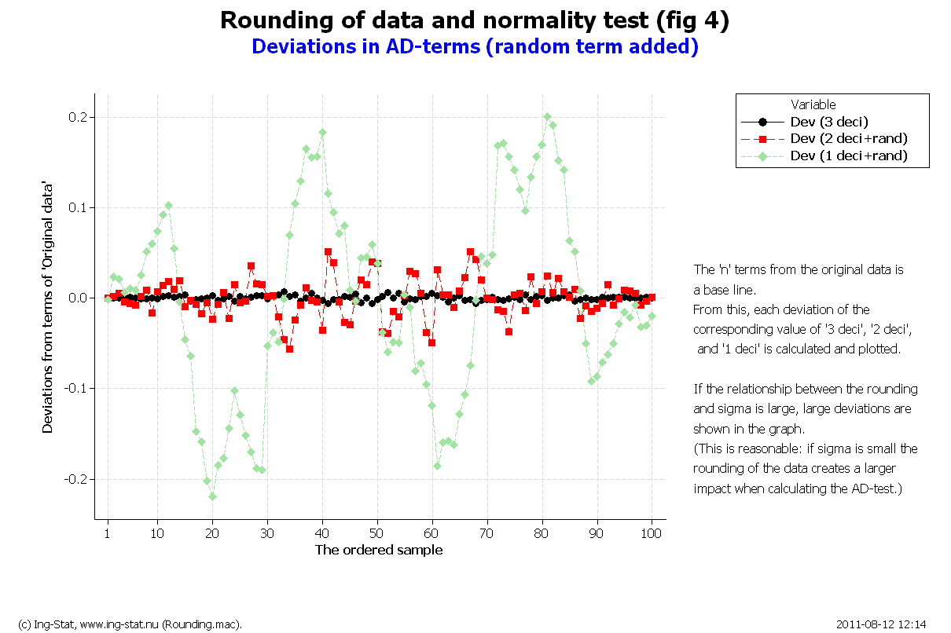 | The diagram shows the same info as in ‘fig 3’ but before the calculations, there is a random term added.  This breaks the pattern shown in ‘fig 3’ and also the size of the deviations (compare the Y-axis of ‘fig 3’ and ‘fig 4’).

Point 6 below summarises the findings above.

6. Summary
This document discusses the AD-statistic used when testing the data against a certain statistical distribution. A large AD-value indicates that the test rejects the hypothesis that the dataset comes from the considered distribution. As usual, the test result is supported by a p-value and with the ordinary interpretation when performing a test of hypothesis.
Industrial data usually contain a small number of decimal places and this must be taken in consideration when performing the AD-test. If the variation of the data is small, there is a tendency that the AD-value is large and thus the hypothesis is rejected. Of course, if the number of decimals is increased this impact is lowered but it is seldom practical or feasable demanding higher numerical accuarcy.
Therefore, even if the AD-value suggests a rejection, the graph itself and knowledge about the technical situation should be used when evaluating the data. Also, a rejection of a distribution means that some other action needs to be considered, a route that might lead to more complications.

Adding a random term. The possibility of adding a random component has many features:

- Often time differences between e.g. two dates (start and stop of some activitiy) give the result 0 timeunits. When trying to apply some standard distributions, the software will refuse to perform the calculations because the length of a time interval of 0 timeunits is impossible (”no activity can take place in no time”). By adding a small positive random value, this problem is avoided.
- Diagrams of data with no or small number of decimals become clearer or better when a small random component is added. Without this addition, points of the diagram might fall on the same spot which visually gives the impact of a small number of data. (Many computet programs have a built in feature called JITTER performing this on graphs.)
- Histograms are often useful in graphical presentations of data. Unfortunately, the limited number of decimals together with the size of the cell (often automatically decided by the software), sometimes give the histogram a strange appearance: a tall bar, a short bar, a tall bar, etc (i.e. every second bar is taller). This can be avoided if a random component is added.

Adding a random component might look as manipulation of the data. However, a rounding of data, either manually or by the measuring device itself, is robbing the data of some information. Thus the addition is a form of returning the truth.

See also ’Tips&tricks’ number 2. ■

