Some comments of partial inspection of a process

The result from an inspection system where only a proportion of the products are inspected can be regarded as a random variable. There are four different results and we can express them as four different probabilities and four different costs. (See also comments and exercises in %CostSim).

We designate the fault rate as p and the inspected proportion as k and we put everything in the following table (a₂ cost because of corrections e.g. at site, a₃ is cost of repair):

 | Result | Probability | Cost
1 | An OK product is not inspected | (1 – p)·(1 – k) | 0
2 | An OK product is inspected | (1 – p)·k | a₁
3 | A not-OK product is not inspected | p·(1 – k) | a₂
4 | A not-OK product is inspected | p·k | a₁ + a₃

The expected cost (μ) is calculated the ordinary way:

$$μ=\sum{a_{i}⋅P(X=a_{i})=0⋅(1−p)⋅(1−k)+k⋅a_{1}⋅(1−p)+a_{2}⋅p⋅(1−k)+(a_{1}+a_{3})}⋅p⋅k$$

which can be simplified to: $μ=k⋅(a_{1}−p⋅(a_{2}−a_{3}))+p⋅a_{2}$

Suppose that a₁ = 500 (inspection cost per product)
a₂ = 12000 (cost because of corrections e.g. at site)
a₃ = 1000 (cost of repair)
p = 0.25 (the current fault rate)
k = 0.55 (the chosen proportion of inspection)

The expected cost becomes: μ = 0.55·(500 – 0.25·(12000 – 1000)) + 0.25·12000 = 1762.50

The discrete distribution of the costs can be simulated using the macro %CreDist in Minitab. (The following lines can be copied and pasted into the session window):

%CreDist # An initial run of the macro.
erase c1 c2 # Erases the input columns.

set c1 # The 'cost input' for this run.
0 500 12000 1500 2000
end

set c2 # The 'probability input' for this run.
0.3375 0.4125 0.1125 0.1375
end

%CreDist # A rerun of the macro.

Five runs of the macro gave the following results: 1660.00, 1716.25, 1717.75, 1723.50, 1544.50 which indicates that the theoretical calculations above are correct.
The distribution produced by %CreDist also shows the influence of the large cost of a not-OK product that is not inspected.
The macro %CostSim, discussed on next page, can also be used to illuminate the situation at hand.

Comments (I)

What is the expected cost if p = 0, i.e. a perfect process, or if k = 0, i.e. nothing is inspected?

Exp cost  when p = 0 | $$\begin{aligned}μ=k⋅(a_{1}−p⋅(a_{2}−a_{3}))+p⋅a_{2} \\ k⋅(a_{1}−0)+0=k⋅a_{1}\end{aligned}$$ | Exp cost  when k = 0 | $$\begin{aligned}μ=k⋅(a_{1}−p⋅(a_{2}−a_{3}))+p⋅a_{2} \\ 0+p⋅a_{2}=p⋅a_{2}\end{aligned}$$

This means that in a perfect process we would get some inspections costs only. However, in a perfect process we hardly would inspect anything at all.
Suppose now that we have a certain fault rate p. Then we must accept the last term, p·a₂, in the expression for the expected cost (see the previous page). What can be said about the first term, k·(a₁ – p·(a₂ – a₃))? When will this term be eliminated? One way is to set k = 0 i.e. no products are inspected. However, we see also that if a₁ – p·(a₂ – a₃) = 0 the first term also will be eliminated. This happens when p has the following, special value, p₀:

$$p_{0}=\frac{a_{1}}{a_{2}−a_{3}}$$ | Suppose that | a₁ = 500  a₂ = 2500  a₃ = 500 | which gives | $$p_{0}=\frac{\text{500}}{\text{2500}−\text{500}}=0\text{.}\text{25}$$

Given these costs, equal to the special value p₀ = 0.25, the first term becomes zero at any value of k, only p·a₂ remains. The macro %CostSim with the stated costs produces the following diagram:

%CostSim # An initial run of the Minitab-macro.
tset c1 # New values for another run.
"1000" "500" "2500" "500"
end
%CostSim # A rerun of the macro.

At p₀ = 0.25 the average cost is p·a₂ = 0.25·2500 = 625 (horizontal dashed line) for all values of k:
- At a lower fault rate the cost increases with increased k  - at a higher fault rate the cost decreases with increased k | This means that at fault rates lower than p₀ (”Limiting p-value” on the diagram) the amount of inspection should be as small as possible and at higher fault rates the fraction of inspection should be as high as possible. (Use the brushing feature for better understanding of the diagram. See also page 4 below.)

Comments (II)

The limiting p-value, $p_{0}=\frac{a_{1}}{a_{2}−a_{3}}$, is only valid when a₁ ≥ 0 and a₂ > a₃.

Try the following settings. The commands in the shaded areas can be entered into the worksheet, column c1, after an initial run of %CostSim:

I | II | III | IV | V
1000  200  6000  500  %CostSim | 1000  0  2500  500  %CostSim | 1000  500  2500  1950  %CostSim | 1000  500  2500  2450  %CostSim | 1000  0  0  0  %CostSim

I The diagrams show that the limiting p-value becomes 0.036. There is a decrease in the average cost for increased inspection proportion (k) for practically all fault rates (p). However the decrease is much more profound at high fault rates, which seems to be reasonable.
Close to the limiting value there is no difference in costs whether we inspect a large or a small fraction; the cost is the same. This depends of course of the fact that we save some money by inspecting the products and fixing the faulty ones, but also that we waste money by the inspecting good products.
The low limiting value (p₀) is caused by the rather large difference between the a₂ and a₃ costs compared to the a₁ cost.

II The a₁ cost (inspection cost) causes limiting value (p₀) to become 0, perhaps a slightly unrealistic case. In this case it is always worthwhile to increase the inspection proportion.

III The diagrams show that the limiting p-value becomes rather high, 0.909, and that any increase in the inspection proportion (k) will increase the average cost, except for the very high fault rates (p).

IV With these costs there is no limiting p-value (’N/A’, not applicable). The average cost increases both with increasing fault rate and inspection proportion. The mathematical expression on the top of the diagram shows that for every percent change of the fault rate the cost changes approximately 25 units. (Run also the %LinModel macro for further illustration of such models.)

V All the costs are zero, thus the average cost is zero everywhere. Note that there is therefore no variation in the diagram. All parameters in the mathematical model are zero as expected.

Conclusion
This document is not by any means exhaustive in regard to applying statistical tools and statistical thinking to the area of cost consideration. However, it interleaves this thinking with a simulation, use of computer software, using good graphs and not the least the notion of a dynamic interactivity with the graphs.
All with the main purpose of creating an understanding of the ongoings and a basis for decisions.

The ’brushing’-feature

After activating the graph by a single click, the ’brush’-button becomes available. (Note that a double click on the graph turns it into editing mode). After clicking the ’brush’-button, a small ’Brush’-window appears. The numbers in this window refer to the rows of the data in the worksheet. This window can be closed if it covers the diagram too much. Also, the cursor becomes a pointing hand.
There are also other possibilities connected to the ’brushing’-feature. See the submenus of the ’Editor’-menu (not ’Edit’). These submenus are available only when the graph is activated and set in ’brushing’-mode. ■

The ’brush’-button

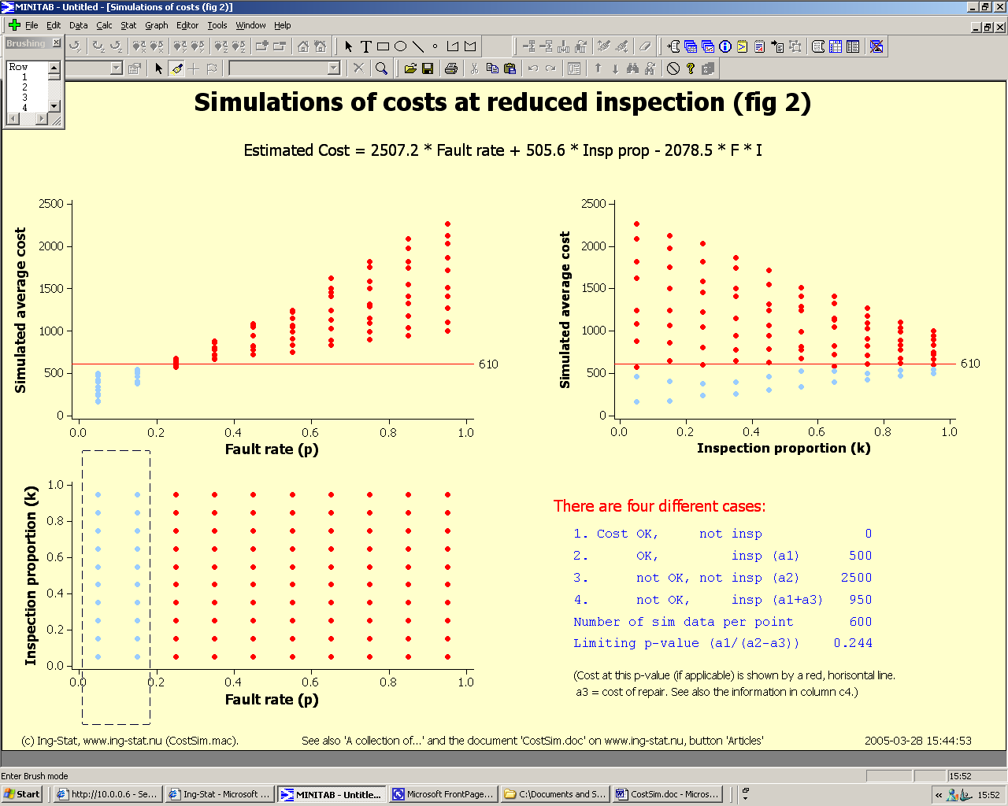

The points enclosed by the brushing-cursor change colours in all diagrams.
See the menu [Tools]>[Options…] Graphics->Data View->Symbol to set the colour.

